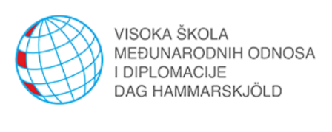

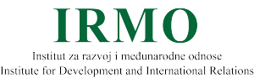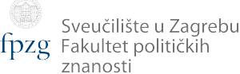

**Invitation to Lecture and Workshop**

We are honored to invite you to a lecture and workshop entitled **Croatia on its way to the Euro – why, how and when?** This event is a part of Jean Monnet **"Learning by Doing: EU Standards in the Balkans"** project, which is coordinated by IRMO’s Department for International Economic and Political Relations, with Faculty of Political Science and Dag Hammarskjöld University College of International Relations and Diplomacy as partners.

Dr. Sc. Mirna Dumičić, a financial stability expert, will raise the following issues in her lecture: Does Croatia "have to" introduce the euro? What is the optimum currency areas (OCA) theory? Is it relevant to Croatia? What are the advantages and disadvantages of introducing the euro, or giving up monetary sovereignty? Which characteristics of the Croatian economy are important in this context? What does introducing the euro look like in practice?

After the lecture students of UCIRD DH will participate in a scenario workshop in which they will debate the effects of the Croatian introduction of the euro.

The lecture and workshop will be held on Tuesday, March 23, 2019 at 4 pm in Lecture Hall 113 at UCIRD DH.

*Program*

|  |  |
| --- | --- |
| Lecture  Croatia on its way to the Euro – why, how and when? | 1600 |
| Discussion | 1700 |
| Refreshments break | 1730 |
| Scenario workshop on effects of eurozone entry | 1800 |

We are looking forward to your arrival!

